Infrastruktur Basis Data Terdistribusi

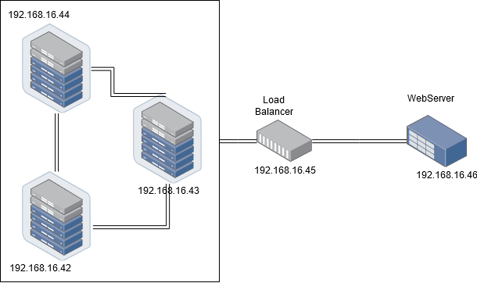

Spesifikasi server

* Server Database - 3 unit
* (192.168.16.42, 192.168.16.43, 192.168.16.44)
* OS: Ubuntu 16.04
* RAM 512 MB
* Database: MySQL
* Load-balancer - 1 unit
  + 192.168.16.45
  + OS: Ubuntu 16.04
  + RAM 512 MB
  + Database: MySQL with ProxySQL
* Webserver - 1 unit
  + 192.168.16.46
  + OS: Ubuntu 16.04
  + RAM 512 MB
  + Webserver: NGINX